EXPERIMENT – 11
AIM :
To develop Python programs using Matplotlib to visualize monthly product sales using a line plot, scatter plot, and bar plot.

ALGORITHM :
- Import the Matplotlib library.
- Store the month names and sales values in lists.
- Use plt.plot() for a line plot.
- Use plt.scatter() for a scatter plot.
- Use plt.bar() for a bar plot.
- Label the axes and give a title.
- Display the plots using plt.show().

CODE :
CODE – LINE PLOT
import matplotlib.pyplot as plt

months = ["Week1", "Week2", "Week3", "Week4"]
sales = [120, 150, 170, 160]

plt.plot(months, sales, marker='o')
plt.xlabel("Weeks")
plt.ylabel("Sales")
plt.title("Monthly Sales Prediction - Line Plot")
plt.grid(True)
plt.show()
CODE – SCATTER PLOT
import matplotlib.pyplot as plt

months = ["Week1", "Week2", "Week3", "Week4"]
sales = [120, 150, 170, 160]

plt.scatter(months, sales)
plt.xlabel("Weeks")
plt.ylabel("Sales")
plt.title("Monthly Sales Prediction - Scatter Plot")
plt.show()
CODE – BAR PLOT
import matplotlib.pyplot as plt

months = ["Week1", "Week2", "Week3", "Week4"]
sales = [120, 150, 170, 160]

plt.bar(months, sales)
plt.xlabel("Weeks")
plt.ylabel("Sales")
plt.title("Monthly Sales Prediction - Bar Plot")
plt.show()

INPUT :
months = ["Week1", "Week2", "Week3", "Week4"]
sales = [120, 150, 170, 160]
OUTPUT :
CODE – LINE PLOT
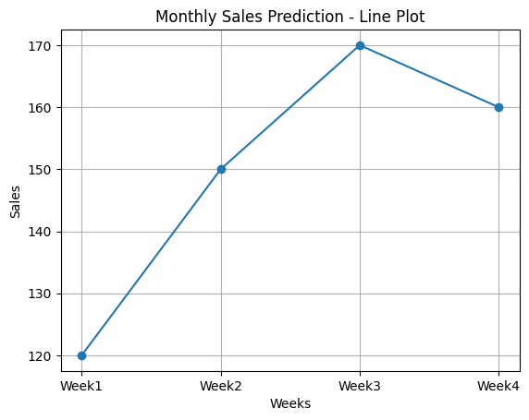
CODE – SCATTER PLOT
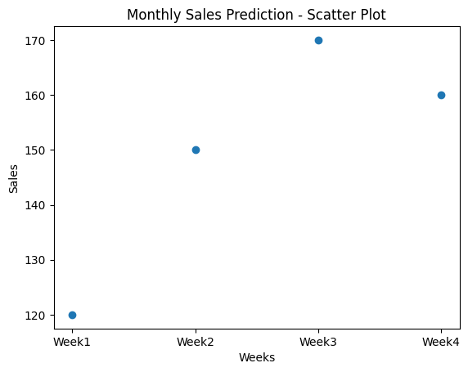

CODE – BAR PLOT
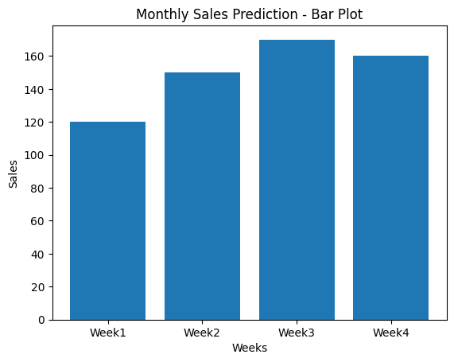

RESULT :
The program successfully generated a line plot, scatter plot, and bar plot to visualize the predicted product sales over a month.

